How to create a personal access token

Step 1

Open your browser and login to GitHub

Go to settings Developer settings

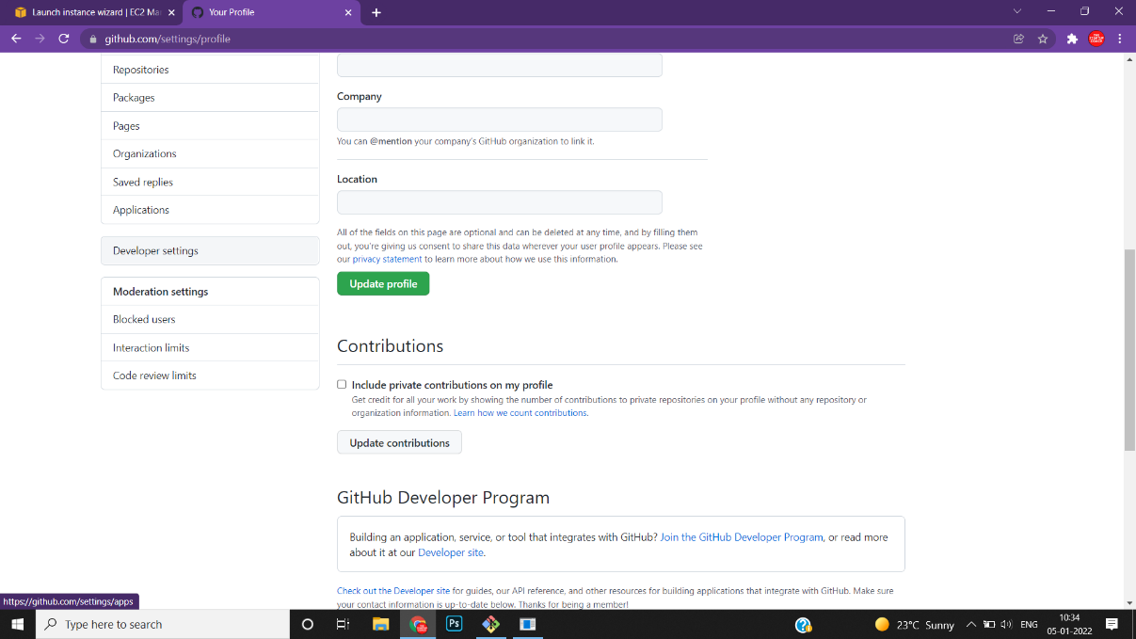

Step 2

In Developer settings select personal access token and generate the token

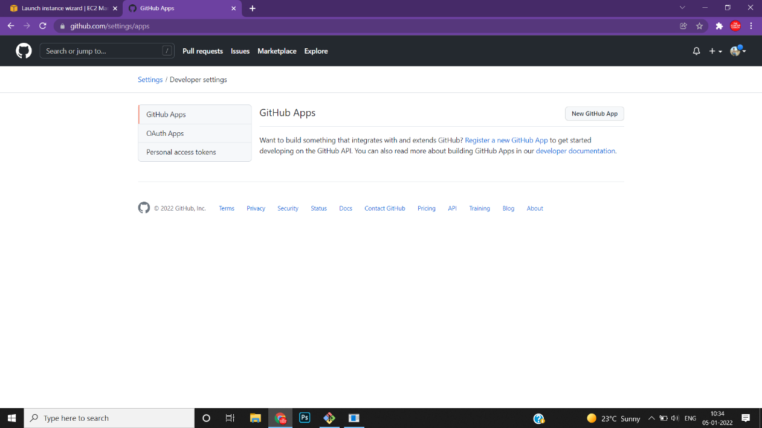

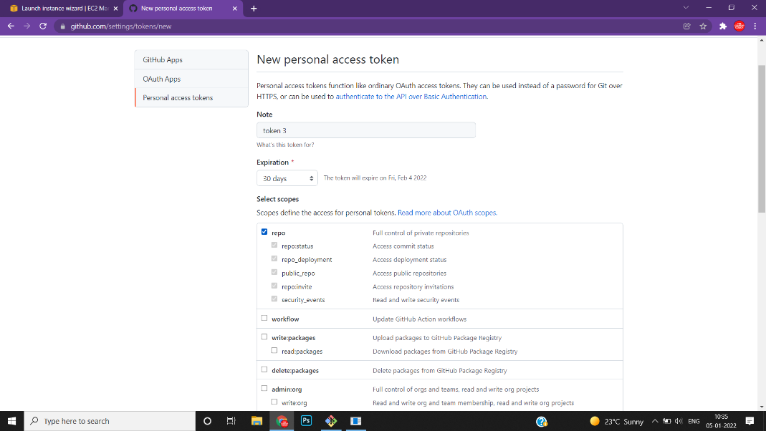

Step 3

Copy your repository URL add it

Git remote add origin



After adding the HTTPS URL push your data to GitHub using command

Git push -u origin main

